Assalamu Alaykum
Dear Brothers,
IMALB is one of the founders and member of the Union of Relief and Development Associations in Lebanon. IMALB would like to emphasize , as agreed in Tanzania Convention, that any FIMA member visiting Lebanon to go thru IMALB and/or coordinate with IMALB.
Damages of Zeina Storm and required preparations to face the winter:
Snowstorm "Zeina" guest applied a burden on Syrian refugees and residents of remote areas in Lebanon, as appropriate weather observatories recorded for the first time in Lebanon, a large decline in temperatures, reached in some areas to 16 degrees below zero.
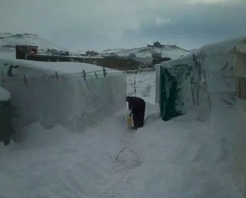

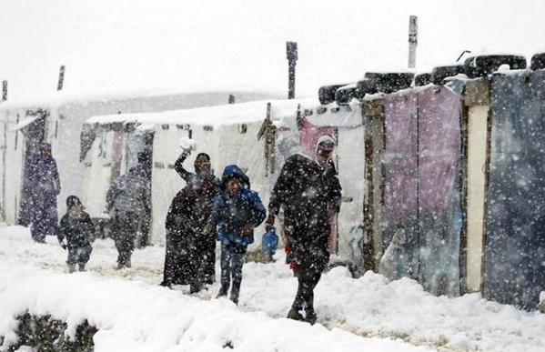
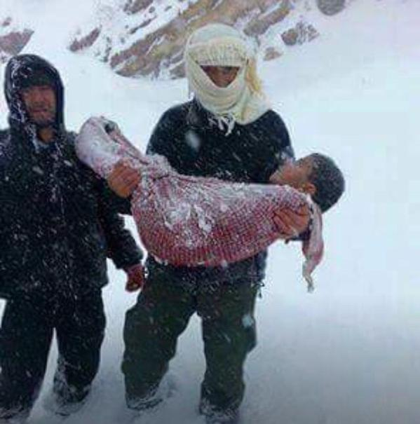
Syrian refugees are freezing to death
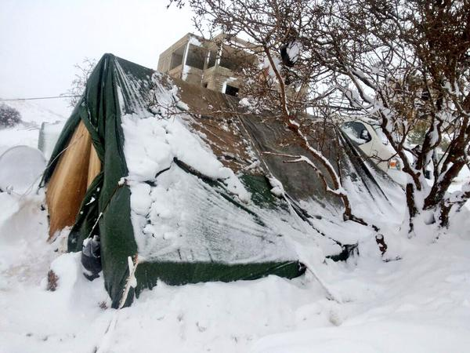
Family of Syrian refugees in Arsal, their tent is collapsing
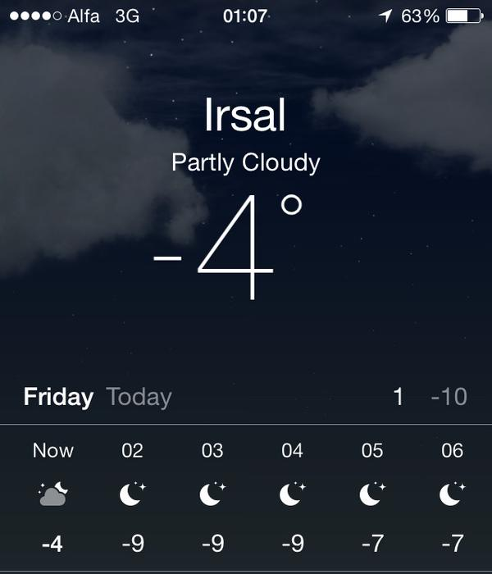

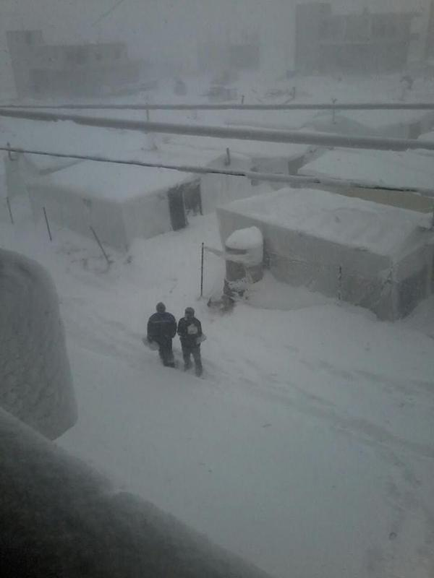

The storm – called “Zeina” in Syria and Lebanon and “Huda” in Jordan – was predicted to be one of the largest in recent memory.
Arsal, a city in northern Lebanon near the Syrian border where thousands of Syrians have fled, has been hit especially hard.
The snow in Arsal appears to be at least a foot deep in pictures widely circulated on social media Wednesday, with more predicated to fall later in the day.
Homeless Syrians tried to prepare for the storm, having been hit by a major snowstorm last winter as well.
“The refugees [in Arsal] have been digging ditches around their camps to avoid flooding,” Nemer al-Qasem, a Syrian media activist currently based in northern Lebanon, told Syria Direct on Tuesday before the snow came.
Syrians in Arsal have established an informal network of refugee camps dispersed around the city, many of which are not officially recognized by the Lebanese government.
Accompanied by the effects of the storm with the first moments of arrival, where roads were closed due to snow accumulation and formation of ice layers, which dismembered areas and led to the besieged people, especially the Syrian refugees who were trapped in vulnerable tents in front of the cold and frost, made of canvas, canvas and nylon.
It is noteworthy that the Federation of relief and development organizations in Lebanon, estimates that the number of Syrian refugees in Lebanon amounted to one million and 619 thousand and 400 refugees by the end of 2014, including 1.2 million registered with the United Nations and distributed on the Lebanese regions as follows: 35% in the Bekaa 0.25% in northern Lebanon 0.18% in Beirut (with its surroundings) 0.12% in southern Lebanon, and the remaining 10% in Mount Lebanon.
This number is huge for Lebanon, which is already suffering from the economic and security problems, and a decline is evident in the level of services, especially in remote and border areas, which was the first destination for Syrian refugees : Arsal Bekaa and South Shebaa and the northern Akkar, was the storm mortal threat to the refugees in those areas that embraced plastic tents.
From here, sought union relief and development organizations in Lebanon, and the rest of the bodies and bodies working in the relief field, to alert medical and relief cadres before and during the storm, worked these authorities to secure the basic needs of Syrian refugees, through the provision of relief and vital services, most notably the food rations, fuel, blankets, medicine and clothing Winter, also stepped up relief of rounds mobile clinics in remote and isolated areas.
The blizzard "Zeina" has been introduced and the rest of the relief agencies and bodies working in the relief field in a new phase of radical change in dealing with extreme weather conditions and natural disasters, impose pre-prepared to deal with disasters and emergencies.
For its part, Igathiyah has worked to activate the emergency relief program, which has allocated a separate budget, and team work of field studies, as well as relief and medical staff working on the ground, and committees of crisis management. The report, part of the studies conducted by the Igathiyah to estimate the current situation, if on the one hand damage control or hand knowledge of the shortcomings of urgent supplies to avoid the largest number of casualties and minimize the negative results later, especially with the continuation of the frost and record temperatures low due to the accumulation of snow and, in light of the possibility of a new form storms could hit Lebanon over the remaining months of winter.
A report
First of all:
Human and material losses in general: the storm claimed the lives of 10 people, most of them Syrian refugees, including seven children, according to medical reports have been dying due to complications brought about the cold and frost after trapped mostly in tents or valleys without food, water or heating. On the other hand, the physical damage exceeding the $ 400,000 only in Syrian refugee camps.

Arsal:
- The number of camps: 72 camps, Union of relief and development organizations in Lebanon takes care of 22 of them which are the largest in space.
- The number of tents / rooms: 4920 tent / room, the Union of relief and development organizations in Lebanon takes care of 1810 tent/room who live in them more than 5,500 families . The estimated population of those tents is 34520 people.
- The number of homes or rented rooms by Syrian refugees in Arsal: almost 5100, in which more than 7,000 families live.
- The number of residents of these houses is estimated at 40 thousand people, due to the high population density compared to the tents. Bringing the number of refugees in Arsal to more than eighty thousand increase after two thousand families living in rooms and homes with more than 600 tents.
- More than 80 tents recorded damaged because of high winds and snow accumulation on them, most of them in random camps.
Arsal was isolated from the outside world during the storm, which led to a shortage of all basic materials, medicines and fuel oil.
Among the most prominent problems during this period was the glaciations of reservoirs and wells, which means that all the camps suffered water outages for 5 consecutive days, and continues until the date of preparation of this report.
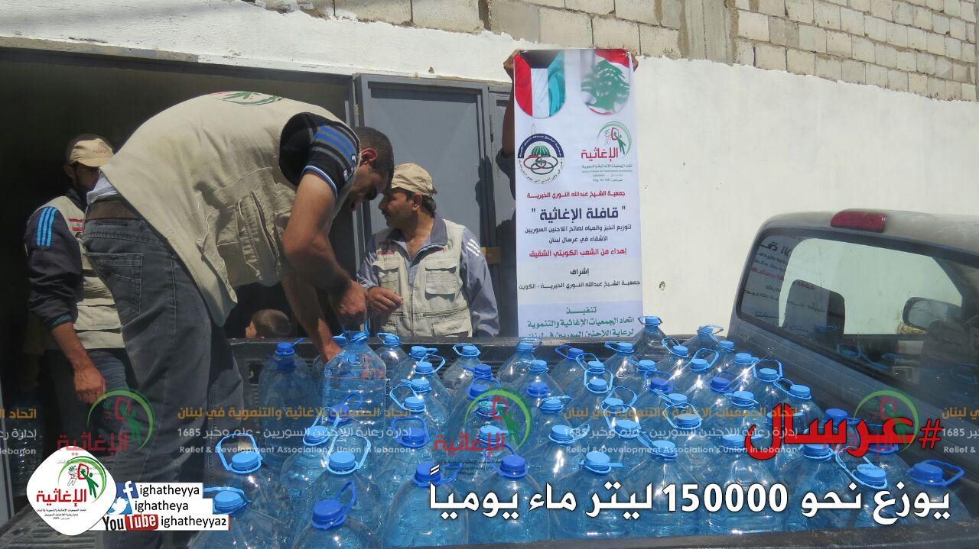
Distributing 150,000 Liters of water / day
Based on the above, and based on the observations and field medical personnel, we offer immediate relief requirements which are as follows:
1 - Nylon tents to protect from the rain (5 thousand out of 10 thousand tent in Lebanon, Nylon tent value with the installation and ropes is $ 35 / tent), a total value of $ 175 thousand.
2- Blankets (200 thousand, value $ 15 / blanket) worth a total of $ 3 million.
3- Carpets (15 thousand carpets, value $ 40/ carpet) worth a total of $ 60 thousand.
4- Mattresses and pillows (100 thousand mattress and pillow, each worth $ 15) a total of $ 1.5 million.
5- heating fuel (diesel) for a week, for a total of 100 thousand families living in remote areas (ie 70 liters per family, at a rate of 10 liters per day, weekly share $ 49 value) totaling $ 4.9 million.
6- heaters (Soabiyat) for a total of 100 thousand families (10 thousand heaters one value of $ 40), a total amount of 400 000 dollars.
- Cold Food Share with bread for one family for a week, for a total of 100 thousand families (100 thousand share, value each $ 25), a total value of $ 2.5 million. To be renewed every week.
- Winter bags for children, containing winter clothes, for about 50 thousand children (50 thousand bag, each worth $ 20) with a total value of $1 million.
- Winter medicines for children, for about 56 thousand children (dosage share value of $ 10), a total value of $ 560 thousand.
- The conduct of 10 mobile clinics for 15 days (the cost of running one clinic per day $ 1,500), total cost of $ 225 thousand.
We hope that in cooperation with several donors and relief associations to secure the required amounts, to overcome the effects of damage caused by the storm, illuminating the damage for the afflicted.

Union of Relief and Development Associations
Unit Studies and Research
It is noteworthy that Arsal is the most Lebanese regions affected by the storm, where the isolated region includes about 40 thousand Lebanese citizen and 80 thousand Syrian refugees from the world as a result of the accumulation of snow, with one hospital, in addition to the field hospital in the town.

Medical wrap
the work of the medical department of Igathiyah is divided into four sections in in line with the requirements of each stage of Syrian refugees presence on Lebanese territory.
- patients section.
- injured. section
- Pharmaceutical section.
- awareness and health education and preparation of paramedics section. (civil defense)
• the opening of a hospital in the border town of Arsal, and receive more than 22,000 patients in the hospital and a 540 surgery under general anesthesia and 715 operation under local anesthesia.
• The Union secured twenty-five prostheses for wounded Syrians, and the launch of several campaigns in order to secure an additional 50 prostheses for the wounded who have undergone amputations.
• Conduct a comprehensive campaign for people with special needs for the distribution of mobility requirements of crutches and wheel chairs , where 170 people with special needs benefited from the campaign and start preparingthe new campaign for a second.
• the conduct of two mobile clinics, one in the northern Bekaa Valley and the other in the East and the West Bekaa.
• The Union secured two ambulances inside Syria, one of Yabrud and other Barada valley's.
• The establishment of the Union and three field hospitals operated fully (Yabrud and Assal roses and a continent).
• Union support drugs and medical supplies (in the area of Beit Jann and Barada valley).
• The establishment of the Union two dispensaries fully equipped in Beirut (kindergarten in the southern suburbs, Dar Al Wafa in Armoun).
• The Union implemented drug projects distributed to 32 clinics for US $ 400,000
• The implementation of the Union dialysis project worth US $ 260,000, which was conducted in 1850 dialysis session.
• The Union is implementing a project Talasmia treatment and blood transfusions valued at US $ 66,000 (approximately 550 a session).
• emergency project has been done to address the chemical war machine in Syria, at a total cost of project chemotherapy 120,000 USD
Foreign bodies that deal with it: there are multiple points of dealing with it, was an international or local.
Geographical spread: Central Medical Department in Beirut, and medical committees in all provinces and cities Lebanese believe effective health care for Syrian refugees in Lebanon.
The total number of beneficiaries: Based on the foregoing, the number of beneficiaries of the achievements of God, help us to achieve about 100,000 Syrian refugees in Lebanon.
Total cost: The total expenditure for medical department since the founding of the Union today to nearly US $ 3.6 million.

In order to secure a living for thousands of Syrian refugees in Lebanon, the work of the Union of relief and development organizations in Lebanon was on the distribution of monthly food rations include most of the necessary materials, which means refugee bridge assuage his hunger and humiliating enough for the question.
We recall some of the achievements of the relief section:
1- Create 17 camps sheltering 12 855 people in each of the transmission and the Bekaa and Akkar and Sidon
2- Food Shares distributed monthly to the camps where the number of shares since the beginning of the establishment of the camps until 2013 "1980" share, equivalent to the amount of $ 285,000 in addition to our registered and who numbered 13319 family, which is equivalent to an amount of $ 293,000, benefiting 76 495 people
3- bread distribution to the camps daily rate of $ 5,000 per month.
4- Secure the seasonal needs of fans and heaters and mattresses and covers and fuel oil and firewood and clothing, carpets etc ..........., The total cost so far of about $ 298.520, where 76 495 people have benefited.
5- distribution of electrical / Freezer devices-heaters - Fans /.
6- Distribution of hygiene shares at a rate of 330 shares for each share of the camps once every two months in 1980 with a total share.
7- supervision of registered refugees data at Union and management in Beirut, where the number of registered families alone 8183 family.
8 - supervision of the 14 social workers inside and outside the camps a monthly salary of $ 500.
9 - Ensure 75 family where the total amount of about $ 153.750.
10 - emergency relief for those coming from the newly risky areas where the total cost of about $ 30,000. in just few days
11 – supervision on the cash distributions inside and outside the camps.
12- Establishing camps and tents receive real-time emergency as needed.
Camp Cham Kalpnian (Arsal)
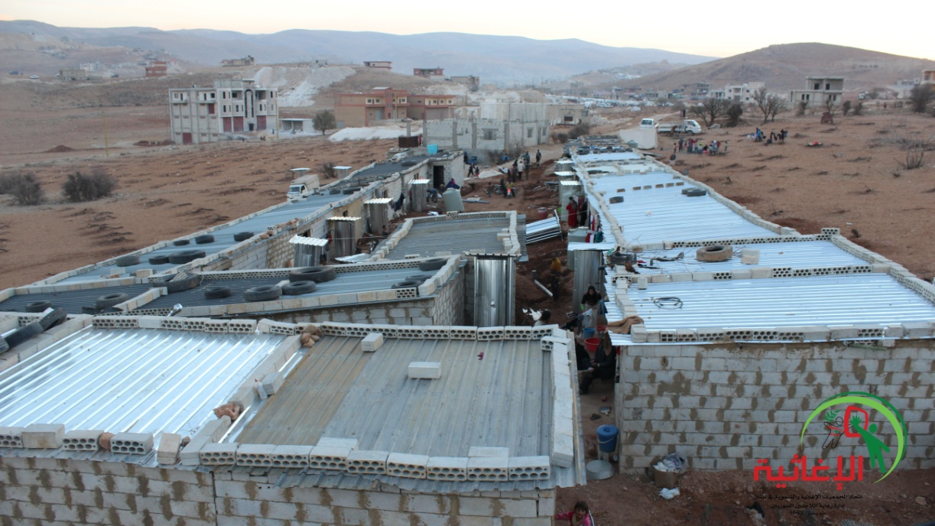

Al Hoson camp (Arsal)
